SY CE2 BATCH-A 220410107055
Practical-1A
Write a Program that displays Welcome to Java, Learning Java Now and Programming is fun.
Program:
public class kushal {
public static void main(String[] args) {
System.out.println("Name: Kushal Parekh");
System.out.println("En. No.: 220410107055");
System.out.println("Welcome to Java");
System.out.println("Learning Java Now");
System.out.println("Programming is fun");
}
}

Output:

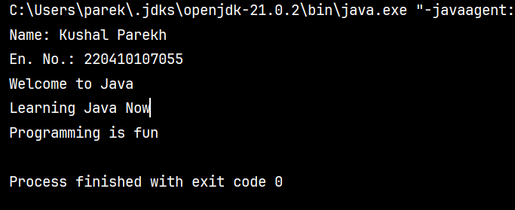
SY CE2 BATCH-A 220410107055
Practical-1B
Write a program that solves the following equation and displays the value x and y:
1) 3.4x+50.2y=44.5
2) 2.1x+.55y=5.9
(Assume Cramer’s rule to solve equation
ax+by=e x=ed-bf/ad-bc
cx+dy=f y=af-ec/ad-bc )
Program:
public class kushal {
public static void main(String[] args) {
System.out.println("Name: Kushal Parekh");
System.out.println("En. No.: 220410107055");
double a = 3.4, b = 50.2, c = 2.1, d = 0.55, e = 44.5, f = 5.9;
double x = (e * d - b * f) / (a * d - b * c);
double y = (a * f - e * c) / (a * d - b * c);
System.out.println("Value of x: " + x);
System.out.println("Value of y: " + y);
}
}

Output:

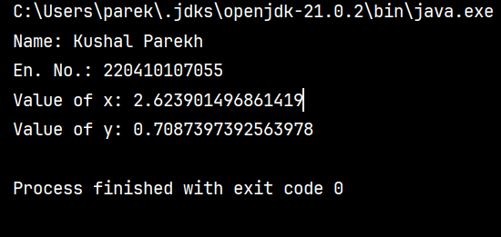

SY CE2 BATCH-A 220410107055
Practical-1C
Write a program that reads a number in meters, converts it to feet, and displays the result.
Program:
import java.util.Scanner;
public class kushal {
public static void main(String[] args) {
System.out.println("Name: Kushal Parekh");
System.out.println("En. No.: 220410107055");
Scanner scanner = new Scanner(System.in);
System.out.print("Enter length in meters: ");
double meters = scanner.nextDouble();
double feet = meters * 3.28084;
System.out.println(meters + " meters is equal to " + feet + " feet.");
scanner.close();
}
}
Output:

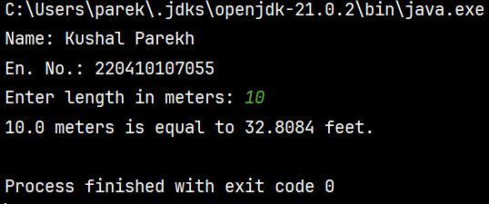

SY CE2 BATCH-A 220410107055
Practical-2A
Body Mass Index (BMI) is a measure of health on weight. It can be calculated by taking your weight in kilograms and dividing by the square of your height in meters. Write a program that prompts the user to enter a weight in pounds and height in inches and displays the BMI. Note:- 1 pound=.45359237 Kg and 1 inch=.0254 meters.
Program:
import java.util.Scanner;
class kushal {
public static void main(String[] args) {
System.out.println("Name: Kushal Parekh");
System.out.println("Enrollment No.: 220410107055");
Scanner input = new Scanner(System.in);
System.out.print("Enter Your weight in Pound : ");
double pound = input.nextDouble();
System.out.print("Enter Your Height in Inch : ");
double inch = input.nextDouble();
double BMI = (pound * 0.45359237) / ((inch * 0.0254) * (inch * 0.0254));
System.out.print("BMI = " + BMI);
}
}

Output:

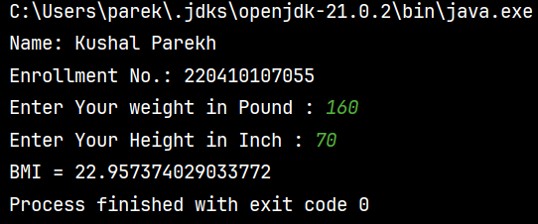

SY CE2 BATCH-A 220410107055
Practical-2B
Write a program that prompts the user to enter three integers and display the integers in decreasing order.
Program:
import java.util.Scanner;
public class kushal {
public static void main(String[] args) {
System.out.println("Name: Kushal Parekh");
System.out.println("En. No.: 220410107055");
Scanner scanner = new Scanner(System.in);
System.out.print("Enter the first integer: ");
int num1 = scanner.nextInt();
System.out.print("Enter the second integer: ");
int num2 = scanner.nextInt();
System.out.print("Enter the third integer: ");
int num3 = scanner.nextInt();
int max = Math.max(Math.max(num1, num2), num3);
int min = Math.min(Math.min(num1, num2), num3);
int mid = (num1 + num2 + num3) - (max + min);
System.out.println("Integers in decreasing order: " + max + ", " + mid + ", " + min);
}
}

Output:

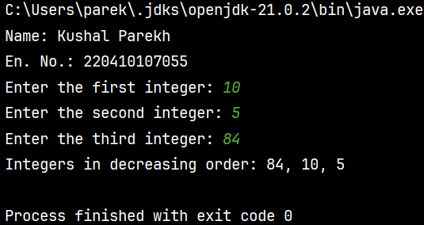

SY CE2 BATCH-A 220410107055
Practical-2C
Write a program that prompts the user to enter a letter and check whether a letter is a vowel or constant.
Program:
import java.util.Scanner;
public class kushal {
public static void main(String[] args) {
System.out.println("Name: Kushal Parekh");
System.out.println("En. No.: 220410107055");
Scanner in = new Scanner(System.in);
System.out.print("Enter a letter: ");
char letter = in.next().toLowerCase().charAt(0);
if ((letter >= 'a' && letter <= 'z')) {
if (letter == 'a' || letter == 'e' || letter == 'i' || letter == 'o' || letter == 'u') {
System.out.println(letter + " is a vowel.");
} else {
System.out.println(letter + " is a consonant.");
}
} else {
System.out.println("Invalid input. Please enter a valid letter.");
}
}
}

Output:

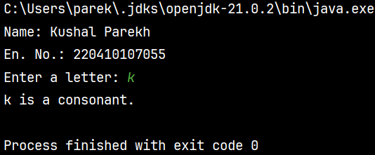

SY CE2 BATCH-A 220410107055
Practical-3A
Assume a vehicle plate number consists of three uppercase letters followed by four digits. Write a program to generate a plate number.
Program:
import java.util.*;
public class kushal{
public static void main(String args[]){
System.out.println("Name: Kushal Parekh");
System.out.println("Enrollment No.: 220410107055");
Random r=new Random();
int i;
System.out.print("Vehical plate number is ");
for(i=0;i<7;i++){
if(i<3){
System.out.print((char)(r.nextInt(26)+65));
}
else{
System.out.print(r.nextInt(10));
}
}
}
}

Output:

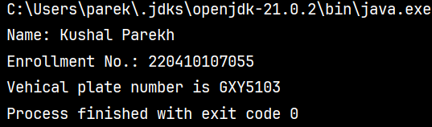

SY CE2 BATCH-A 220410107055
Practical-3B
Write a program that reads an integer and displays all its smallest factors in increasing order. For example if input number is 120, the output should be as follows:2,2,2,3,5.
Program:
import java.util.Scanner;
public class kushal {
public static void main(String[] args) {
System.out.println("Name: Kushal Parekh");
System.out.println("En. No.: 220410107055");
Scanner sc = new Scanner(System.in);
System.out.print("Enter an integer: ");
int number = sc.nextInt();
System.out.print("Smallest factors of " + number + " in increasing order: ");
for (int i = 2; i <= number; i++) {
while (number % i == 0) {
System.out.print(i);
if (number != i) {
System.out.print(",");
}
number /= i;
}
}
}
}

Output:

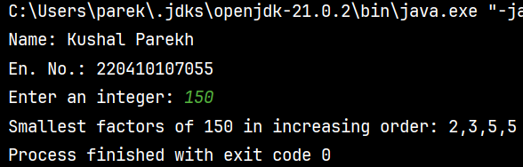
SY CE2 BATCH-A 220410107055
Practical-4A
Write a method with following method header: public static int gcd(int num1, int num2). Write a program that prompts the user to enter two integers and compute the gcd of two integers.
Program:
import java.util.Scanner;
public class kushal {
public static void main(String[] args) {
System.out.println("Name: Kushal Parekh");
System.out.println("En. No.: 220410107055");
Scanner sc = new Scanner(System.in);
System.out.print("Enter the first integer: ");
int num1 = sc.nextInt();
System.out.print("Enter the second integer: ");
int num2 = sc.nextInt();
int gcdResult = gcd(num1, num2);
System.out.println("The greatest common divisor (GCD) of " + num1 + " and " + num2 + " is: " + gcdResult);
}
public static int gcd(int num1, int num2) {
while (num2 != 0) {
int temp = num2;
num2 = num1 % num2;
num1 = temp;
}
return num1;
}
}

Output:

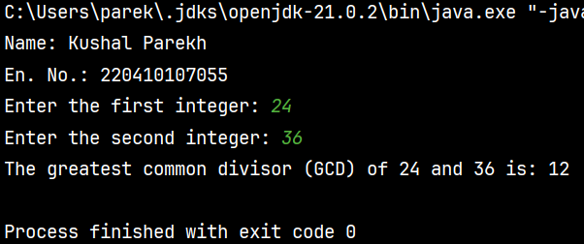

SY CE2 BATCH-A 220410107055
Practical-4B
Write a test program that prompts the user to enter ten numbers, invoke a method to reverse the numbers, display the numbers.
Program:
import java.util.Scanner;
public class kushal {
public static void main(String[] args) {
System.out.println("Name: Kushal Parekh");
System.out.println("En. No.: 220410107055");
Scanner sc = new Scanner(System.in);
int[] numbers = new int[10];
System.out.println("Enter ten numbers:");
for (int i = 0; i < 10; i++) {
System.out.print("Number " + (i + 1) + ": ");
numbers[i] = sc.nextInt();
}
revNum(numbers);
System.out.println("Reversed numbers:");
for (int number : numbers) {
System.out.print(number + " ");
}
}
public static void revNum(int[] numbers) {
int left = 0;
int right = numbers.length - 1;
while (left < right) {
int temp = numbers[left];
numbers[left] = numbers[right];
numbers[right] = temp;
left++;
right--;
}
}
}

Output:

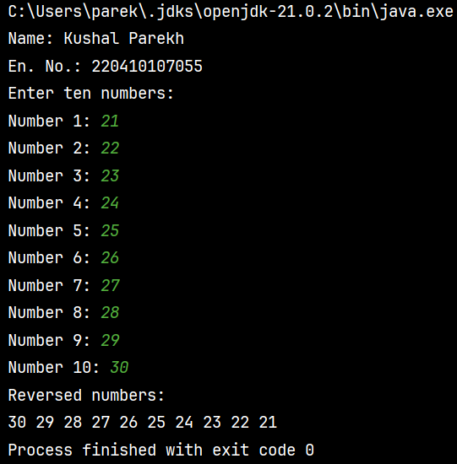

SY CE2 BATCH-A 220410107055
Practical-4C
Write a program that generate 6*6 two-dimensional matrix, filled with 0’s and 1’s , display the matrix, check every raw and column have an odd number’s of 1’s.
Program:
import java.util.Random;
public class kushal {
public static void main(String[] args) {
System.out.println("Name: Kushal Parekh");
System.out.println("En. No.: 220410107055");
int[][] matrix = generateMatrix();
System.out.println("Generated Matrix:");
displayMatrix(matrix);
boolean isOddRowColumn = checkOddRowColumn(matrix);
if (isOddRowColumn) {
System.out.println("Every row and column have an odd number of 1's.");
} else {
System.out.println("Not every row and column have an odd number of 1's.");
}
}
public static int[][] generateMatrix() {
int[][] matrix = new int[6][6];
Random random = new Random();
for (int i = 0; i < 6; i++) {
for (int j = 0; j < 6; j++) {
matrix[i][j] = random.nextInt(2);
}
}
return matrix;
}
public static void displayMatrix(int[][] matrix) {
for (int i = 0; i < matrix.length; i++) {
for (int j = 0; j < matrix[0].length; j++) {
System.out.print(matrix[i][j] + " ");
}
System.out.println();
}
}
public static boolean checkOddRowColumn(int[][] matrix) {
for (int i = 0; i < matrix.length; i++) {
int rowSum = 0;
int colSum = 0;
for (int j = 0; j < matrix[0].length; j++) {
rowSum += matrix[i][j];
colSum += matrix[j][i];
}
if (rowSum % 2 == 0 || colSum % 2 == 0) {
return false;
}
}
return true;
}
}

Output:

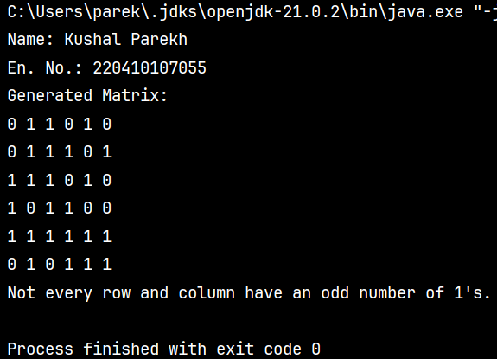

SY CE2 BATCH-A 220410107055
Practical-5A
Write a program that creates a Random object with seed 1000 and displays the first 100 random integers between 1 and 49 using the NextInt (49) method.
Program:
import java.util.Random;
public class kushal {
public static void main(String[] args) {
System.out.println("Name: Kushal Parekh");
System.out.println("En. No.: 220410107055");
Random random = new Random(1000);
System.out.println("First 100 random integers between 1 and 49:");
for (int i = 0; i < 100; i++) {
int randomNumber = random.nextInt(49) + 1;
System.out.print(randomNumber + " ");
if ((i + 1) % 20 == 0) {
System.out.println();
}
}
}
}

Output:

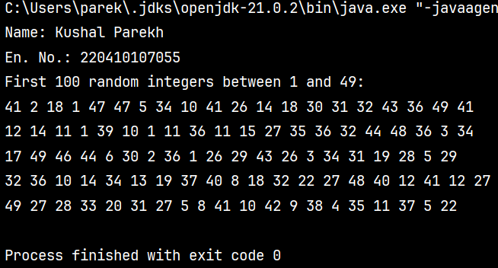

SY CE2 BATCH-A 220410107055
Practical-5B
Write a program for calculator to accept an expression as a string in which the operands and operator are separated by zero or more spaces. For ex: 3+4 and 3 + 4 are acceptable expressions.
Program:
import java.util.Scanner;
public class kushal {
public static void main(String[] args) {
System.out.println("Name: Kushal Parekh");
System.out.println("En. No.: 220410107055");
Scanner sc = new Scanner(System.in);
System.out.print("Enter an expression: ");
String expression = sc.nextLine();
expression = expression.replaceAll("\\s", "");
char operator = 0;
int operand1 = 0;
int operand2 = 0;
for (int i = 0; i < expression.length(); i++) {
char ch = expression.charAt(i);
if (ch == '+' || ch == '-' || ch == '*' || ch == '/') {
operator = ch;
operand1 = Integer.parseInt(expression.substring(0, i));
operand2 = Integer.parseInt(expression.substring(i + 1));
break;
}
}
int result = 0;
switch (operator) {
case '+':
result = operand1 + operand2;
break;
case '-':
result = operand1 - operand2;
break;
case '*':
result = operand1 * operand2;
break;
case '/':
if (operand2 != 0) {
result = operand1 / operand2;
} else {
System.out.println("Error: Division by zero");
return;
}
break;
default:
System.out.println("Error: Invalid operator");
return;
}
System.out.println("Result: " + result);
}
}

Output:

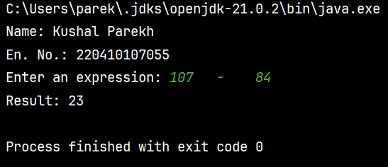

SY CE2 BATCH-A 220410107055
Practical-6A
Write a program that creates an Array List and adds a Loan object , a Date object , a string, and a Circle object to the list, and use a loop to display all elements in the list by invoking the object’s to String() method.
Program:
import java.util.ArrayList;
import java.util.Date;
class Loan {
private double amount;

public Loan(double amount) {
this.amount = amount;
}
public String toString() {
return "Loan: " + amount;
}
}
class Circle {
private double radius;
public Circle(double radius) {
this.radius = radius;
}
public String toString() {
return "Circle: radius = " + radius;
}
}
public class kushal {
public static void main(String[] args) {
System.out.println("Name: Kushal Parekh");
System.out.println("En. No.: 220410107055");
ArrayList<Object> list = new ArrayList<>();
list.add(new Loan(1000));
list.add(new Date());
list.add("Hello");
list.add(new Circle(5.0));
System.out.println("Elements in the list:");
for (Object obj : list) {
System.out.println(obj.toString());
}
}
}

Output:

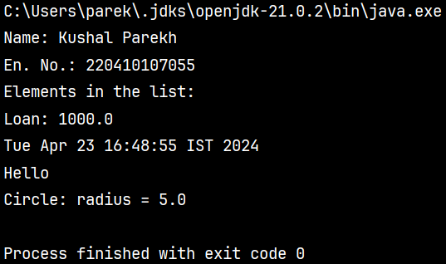

SY CE2 BATCH-A 220410107055
Practical-6B
Write the bin2Dec (string binary String) method to convert a binary string into a decimal number. Implement the bin2Dec method to throw a NumberFormatException if the string is not a binary string.
Program:
public class kushal {
public static void main(String[] args) {
System.out.println("Name: Kushal Parekh");
System.out.println("En. No.: 220410107055");
try {
String binaryString = "1010101";
int decimalNumber = bin2Dec(binaryString);
System.out.println("Binary string: " + binaryString);
System.out.println("Decimal number: " + decimalNumber);
} catch (NumberFormatException e) {
System.out.println("Invalid binary string: " + e.getMessage());
}
try {
String invalidBinaryString = "12345";
int decimalNumber = bin2Dec(invalidBinaryString);
System.out.println("Binary string: " + invalidBinaryString);
System.out.println("Decimal number: " + decimalNumber);
} catch (NumberFormatException e) {
System.out.println("Invalid binary string: " + e.getMessage());
}
}
public static int bin2Dec(String binaryString) {
for (char ch : binaryString.toCharArray()) {
if (ch != '0' && ch != '1') {
throw new NumberFormatException("String is not a binary string");
}
}
int decimal = 0;
for (int i = binaryString.length() - 1, power = 0; i >= 0; i--, power++) {
if (binaryString.charAt(i) == '1') {
decimal += Math.pow(2, power);
}
}
return decimal;
}
}

Output:

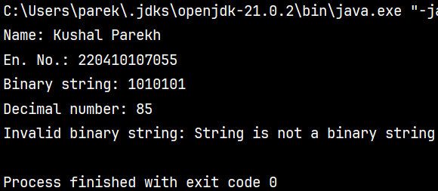

SY CE2 BATCH-A 220410107055
Practical-7A
Write a program that prompts the user to enter a decimal number and displays the number in a fraction. Hint: Read the decimal number as a string, extract the integer part and fractional part from the string.
Program:
import java.util.Scanner;
public class kushal {
public static void main(String[] args) {
System.out.println("Name: Kushal Parekh");
System.out.println("En. No.: 220410107055");
Scanner scanner = new Scanner(System.in);
System.out.print("Enter a decimal number: ");
String decimalString = scanner.nextLine();
String[] parts = decimalString.split("\\.");
int integerPart = Integer.parseInt(parts[0]);
String fractionalPart = "0";
if (parts.length > 1) {
fractionalPart = parts[1];
}
int denominator = (int) Math.pow(10, fractionalPart.length());
int fractionalPartInt = Integer.parseInt(fractionalPart);
int gcd = gcd(fractionalPartInt, denominator);
int numerator = fractionalPartInt / gcd;
denominator /= gcd;
System.out.println("Fraction representation:");
System.out.println(integerPart * denominator + numerator + "/" + denominator);
}
public static int gcd(int num1, int num2) {
while (num2 != 0) {
int temp = num2;
num2 = num1 % num2;
num1 = temp;
}
return num1;
}
}

Output:

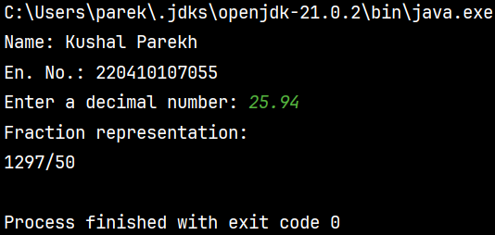

SY CE2 BATCH-A 220410107055
Practical-7B
Write a program that displays a tic-tac-toe board. A cell may be X, O, or empty. What to display at each cell is randomly decided. The X and O are images in the files X.gif and O.gif.
Program:
import javafx.application.Application;
import javafx.scene.Scene;
import javafx.scene.image.Image;
import javafx.scene.image.ImageView;
import javafx.scene.layout.GridPane;
import javafx.scene.layout.Vbox;
import javafx.stage.Stage;
import java.io.FileInputStream;
import java.io.FileNotFoundException;
public class Main extends Application {
@Override
public void start(Stage primaryStage) {
primaryStage.setTitle(“Tic-Tac-Toe”);
GridPane gridPane = new GridPane();
generateRandomBoard(gridPane);
Scene primaryScene = new Scene(gridPane, 300, 300);
primaryStage.setScene(primaryScene);
primaryStage.show();
}
private void generateRandomBoard(GridPane gridPane) {
for (int I = 0; I < 3; i++) {
for (int j = 0; j < 3; j++) {
int n = (int) (Math.random() * 3);
if (n == 0)
gridPane.add(createX(), I, j);
else if (n == 1)
gridPane.add(createO(), I, j);
}}}
private Vbox createX() {
ImageView imageViewX = createImageView(“D:/New folder/X_modified.png”);
return setImageViewProperties(imageViewX);
}
private Vbox createO() {
ImageView imageViewO = createImageView(“D:/New folder/o_modified.png/”);
return setImageViewProperties(imageViewO);
}
private ImageView createImageView(String imagePath) {
try {
Image image = new Image(new FileInputStream(imagePath));
return new ImageView(image);
} catch (FileNotFoundException e) {
e.printStackTrace();
return null;
}}
private Vbox setImageViewProperties(ImageView iv) {
iv.setFitHeight(50);
iv.setFitWidth(50);
iv.setPreserveRatio(true);
Vbox vBox = new Vbox();
vBox.getChildren().add(iv);
vBox.setStyle(“-fx-border-color: orange”);
return vBox;
}
public static void main(String[] args) {
launch(args);
}}
Output:

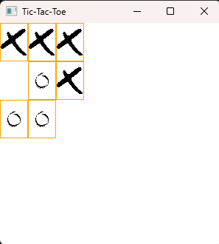

SY CE2 BATCH-A 220410107055
Practical-8A
Write a program that moves a circle up, down, left or right using arrow keys.
Program:
import javafx.application.Application;
import javafx.scene.Scene;
import javafx.scene.shape.Circle;
import javafx.scene.layout.Pane;
import javafx.geometry.Insets;
import javafx.stage.Stage;
public class Main extends Application
{
@Override
public void start(Stage primaryStage) {
Pane pane = new Pane();
pane.setPadding(new Insets(30, 30, 30, 30));
Circle circle = new Circle(30, 30, 30);
pane.getChildren().add(circle);
pane.setOnKeyPressed(e -> {
switch (e.getCode()) {
case UP : circle.setCenterY(circle.getCenterY() >
circle.getRadius() ? circle.getCenterY() - 15 :
circle.getCenterY()); break;
case DOWN : circle.setCenterY(circle.getCenterY() <
pane.getHeight() - circle.getRadius() ?
circle.getCenterY() + 15 : circle.getCenterY());
break;
case LEFT : circle.setCenterX(circle.getCenterX() >
circle.getRadius() ? circle.getCenterX() - 15 :
circle.getCenterX()); break;
case RIGHT : circle.setCenterX(circle.getCenterX() <
pane.getWidth() - circle.getRadius() ?
circle.getCenterX() + 15: circle.getCenterX());
}});
Scene scene = new Scene(pane, 200, 200);
primaryStage.setTitle("OOP_18");
primaryStage.setScene(scene);
primaryStage.show();
pane.requestFocus();
}}
Output:

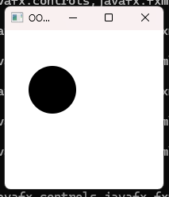

SY CE2 BATCH-A 220410107055
Practical-8B
Write a program that displays the color of a circle as red when the mouse button is pressed and as blue when the mouse button is released.
Program:
import javax.swing.*;
import java.awt.*;
import java.awt.event.MouseAdapter;
import java.awt.event.MouseEvent;
public class Prac8_2 extends JFrame {
private Color circleColor;
public Prac8_2() {
setTitle("Change Color");
setSize(400, 400);
setDefaultCloseOperation(EXIT_ON_CLOSE);
setLocationRelativeTo(null);
circleColor = Color.BLUE;
JPanel panel = new JPanel() {
@Override
protected void paintComponent(Graphics g) {
super.paintComponent(g);
g.setColor(circleColor);
int diameter = 100;
int x = (getWidth() - diameter) / 2;
int y = (getHeight() - diameter) / 2;
g.fillOval(x, y, diameter, diameter);
}};
panel.addMouseListener(new MouseAdapter() {
@Override
public void mousePressed(MouseEvent e) {
circleColor = Color.RED;
panel.repaint();
}
public void mouseReleased(MouseEvent e) {
circleColor = Color.BLUE;
panel.repaint();
}});
getContentPane().add(panel);
setVisible(true);
}
public static void main(String[] args) {
SwingUtilities.invokeLater(() -> new Prac8_2());
}}

Output:

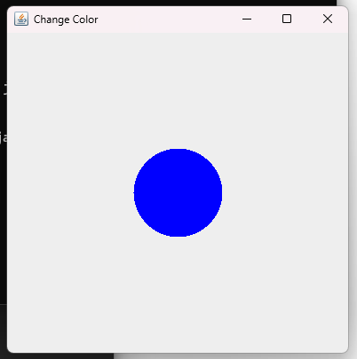

SY CE2 BATCH-A 220410107055
Practical-8C
Write a GUI program that use button to move the message to the left and right and use the radio button to change the color for the message displayed.
Program:
import javafx.application.Application;
import javafx.stage.Stage;
import javafx.scene.Scene;
import javafx.geometry.Pos;
import javafx.scene.control.Button;
import javafx.scene.layout.HBox;
import javafx.scene.layout.Pane;
import javafx.scene.layout.BorderPane;
import javafx.scene.text.Text;
import javafx.scene.control.RadioButton;
import javafx.scene.control.ToggleGroup;
import javafx.scene.paint.Color;
public class Prac8_3 extends Application {
Text text = new Text(50, 50, "Hello !!!");
public void start(Stage primaryStage) {
HBox paneForButtons = new HBox(20);
Button btLeft = new Button("<=");
Button btRight = new Button("=>");
paneForButtons.getChildren().addAll(btLeft, btRight);
paneForButtons.setAlignment(Pos.CENTER);
BorderPane pane = new BorderPane();
pane.setBottom(paneForButtons);
HBox paneForRadioButtons = new HBox(20);
RadioButton rbRed = new RadioButton("Red");
RadioButton rbBlue = new RadioButton("Blue");
RadioButton rbWhite = new RadioButton("White");
RadioButton rbOrange = new RadioButton("Orange");
RadioButton rbGreen = new RadioButton("Green");
paneForRadioButtons.getChildren().addAll(rbRed, rbBlue, rbWhite, rbOrange,
rbGreen);
ToggleGroup group = new ToggleGroup();
rbRed.setToggleGroup(group);
rbBlue.setToggleGroup(group);
rbWhite.setToggleGroup(group);
rbOrange.setToggleGroup(group);
rbGreen.setToggleGroup(group);
Pane paneForText = new Pane();
paneForText.setStyle("-fx-border-color: black");
paneForText.getChildren().add(text);
pane.setCenter(paneForText);
pane.setTop(paneForRadioButtons);
btLeft.setOnAction(e -> text.setX(text.getX() - 10));
btRight.setOnAction(e -> text.setX(text.getX() + 10));
rbRed.setOnAction(e -> {
if (rbRed.isSelected()) {
text.setFill(Color.RED);
}});
rbBlue.setOnAction(e -> {
if (rbBlue.isSelected()) {
text.setFill(Color.BLUE);
}});
rbWhite.setOnAction(e -> {
if (rbWhite.isSelected()) {
text.setFill(Color.WHITE);
}});
rbOrange.setOnAction(e -> {
if (rbOrange.isSelected()) {
text.setFill(Color.ORANGE);
}});
rbGreen.setOnAction(e -> {
if (rbGreen.isSelected()) {
text.setFill(Color.GREEN);
}});
Scene scene = new Scene(pane, 450, 150);
primaryStage.setTitle("Move the text and change its color");
primaryStage.setScene(scene);
primaryStage.show();
}
public static void main(String[] args) {
launch(args);
}}
Output:

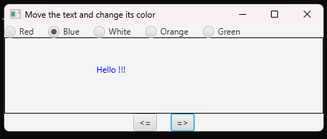

SY CE2 BATCH-A 220410107055
Practical-9A
Write a program to create a file name 123.txt, if it does not exist. Append a new data to it if it already exist. Write 150 integers created randomly into the file using Text I/O. Integers are separated by space.
Program:
import java.io.*;
import java.util.Scanner;
public class Main{
public static void main(String[] args)
{
System.out.println("Name: Kushal Parekh \nEn No.: 220410107055");
try (
PrintWriter pw = new PrintWriter(new FileOutputStream(new File("P_91.txt"), true));
) {for (int i = 0; i < 150; i++)
{
pw.print((int)(Math.random() * 150) +"\t");
} }
catch (FileNotFoundException fnfe) {
System.out.println("Cannot create the file.");
System.out.println("Name: Drashan Panchal \nEn No.: 220410107050");
fnfe.printStackTrace();
} } }
Output:

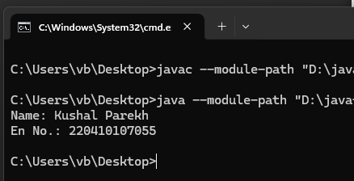
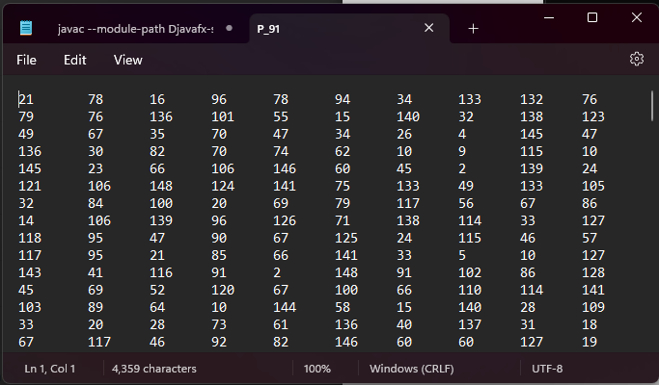

SY CE2 BATCH-A 220410107055
Practical-9B
Write a recursive method that returns the smallest integer in an array. Write a test program that prompts the user to enter an integer and display its product.
Program:
import java.util.Scanner;
public class Main {
public static int findMinimum(int A[], int n){
if(n == 1)
return A[0];
return Math.min(A[n-1], findMinimum(A, n-1));
}
public static void main(String args[]){
System.out.println("NAME : Kushal Parekh");
System.out.println("ENROLLMENT NO. : 220410107055\n");
Scanner sc= new Scanner(System.in);
System.out.print("How many elements you want in array? - ");
int n = sc.nextInt();
int A[] = new int[n];
for (int i=0;i<n;i++){
A[i]=sc.nextInt();
}
System.out.println("Smallest element in the array is: "+findMinimum(A, n));
}}

Output:

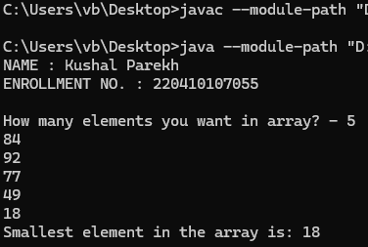

SY CE2 BATCH-A 220410107055
Practical-9C
Write a generic method that returns the minimum elements in a two dimensional array.
Program:
public class Main{
public static void main(String[] args) {
System.out.println("NAME : Kushal Parekh");
System.out.println("ENROLLMENT NO. : 220410107055\n");
Integer list[][] = new Integer[10][10];
int value = 0;
for (int i = 0; i < list.length; i++) {
for (int j = 0; j < list[i].length; j++) {
list[i][j] = ++value;
}}
System.out.println("Minimum no is = " + min(list));
}
public static <E extends Comparable<E>>E min(E list[][]) {
E min = list[0][0];
for (E[] elements : list) {
for (E element : elements) {
if (element.compareTo(min) < 0) {
min = element;
}}}
return min;
}}
Output:
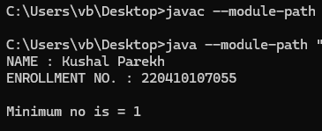
SY CE2 BATCH-A 220410107055
Practical-10A
Define MYPriorityQueue class that extends Priority Queue to implement the Cloneable interface and implement the clone() method to clone a priority queue.
Program:
import java.util.PriorityQueue;
public class MYPriorityQueue<E> extends PriorityQueue<E> implements Cloneable {
public MYPriorityQueue() {
super();
}
public MYPriorityQueue<E> clone() {
MYPriorityQueue<E> clonedQueue = new MYPriorityQueue<>();
clonedQueue.addAll(this);
return clonedQueue;
}
public static void main(String[] args) {
System.out.println("NAME : Kushal Parekh");
System.out.println("ENROLLMENT NO. : 220410107055\n");
MYPriorityQueue<Integer> originalQueue = new MYPriorityQueue<>();
originalQueue.add(3);
originalQueue.add(1);
originalQueue.add(2);
MYPriorityQueue<Integer> clonedQueue = originalQueue.clone();
System.out.println("Original Queue: " + originalQueue);
System.out.println("Cloned Queue: " + clonedQueue);
}}

Output:

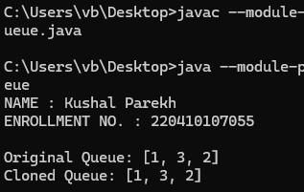

SY CE2 BATCH-A 220410107055
Practical-10B
Write a program that reads words from a text file and displays all the nonduplicate words in descending order.The text file is passed as a command-line argument.
Program:
import java.io.*;
import java.util.*;
class Main{
public static void main(String[] args) {
System.out.println("NAME : Darshan Panchal");
System.out.println("ENROLLMENT NO. : 220410107050\n");
if (args.length == 1) {
String fileName = args[0];
TreeSet <String>set = new TreeSet <>();
File file = new File(fileName);
try {
Scanner s = new Scanner(file);
while (s.hasNext()) {
set.add(s.next());
}
System.out.println(set);
} catch (FileNotFoundException e) {
e.printStackTrace();
}} else {
System.out.println("Please, Pass the File Name as Command Line Argument");
}}}

Output:

