SARDAR VALLABHBHAI PATEL INSTITUTE OF TECHNOLOGY, VASAD
COMPUTER ENGINNERING DEPT
Theory of Computation
TY – CE

Assignment of CHAPTER 3

Text Book: John C Martin, 3rd Edition

S.No | Chapter | Assignment Exercise
1 | Ch-3 | 3.1,3.2,3.3,3.4, 3.8, 3.9,3.19,3.20, 3.22, 3.33,3.36,3.43

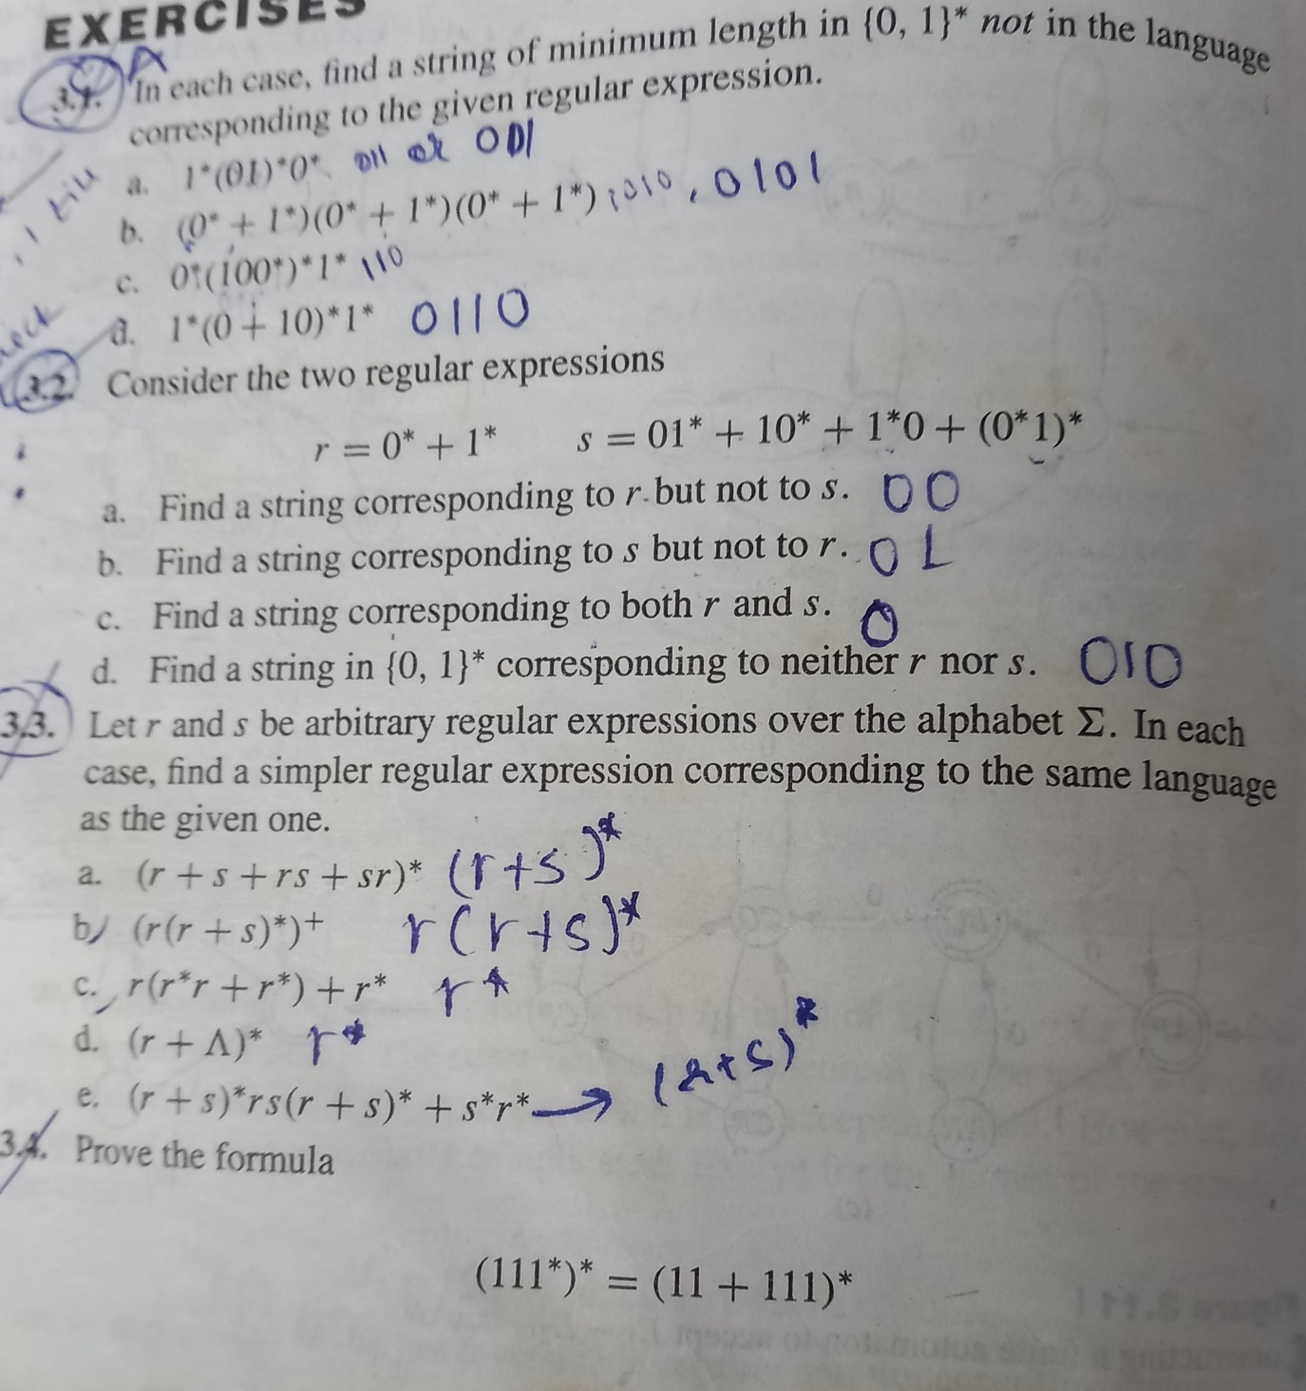
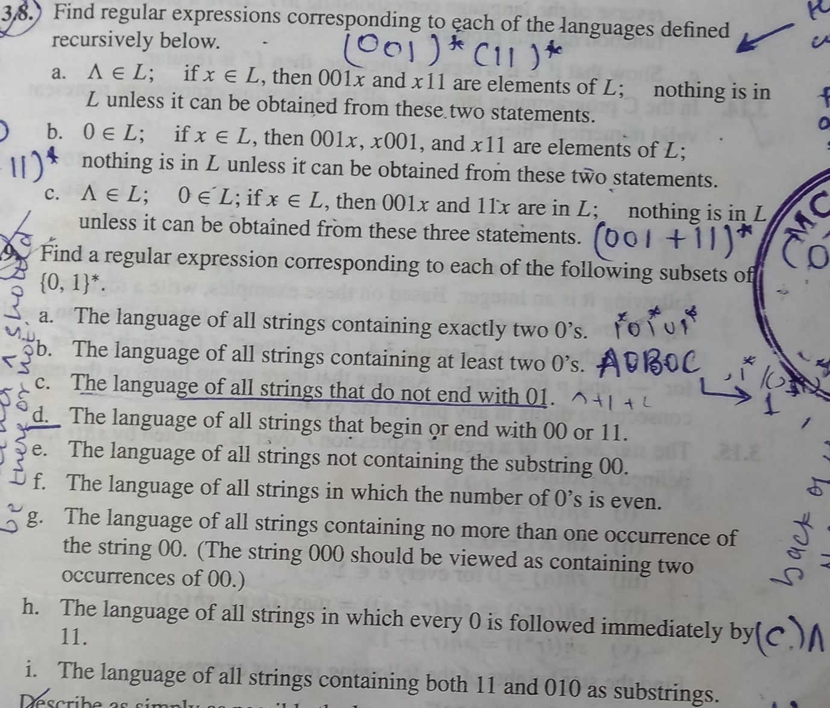

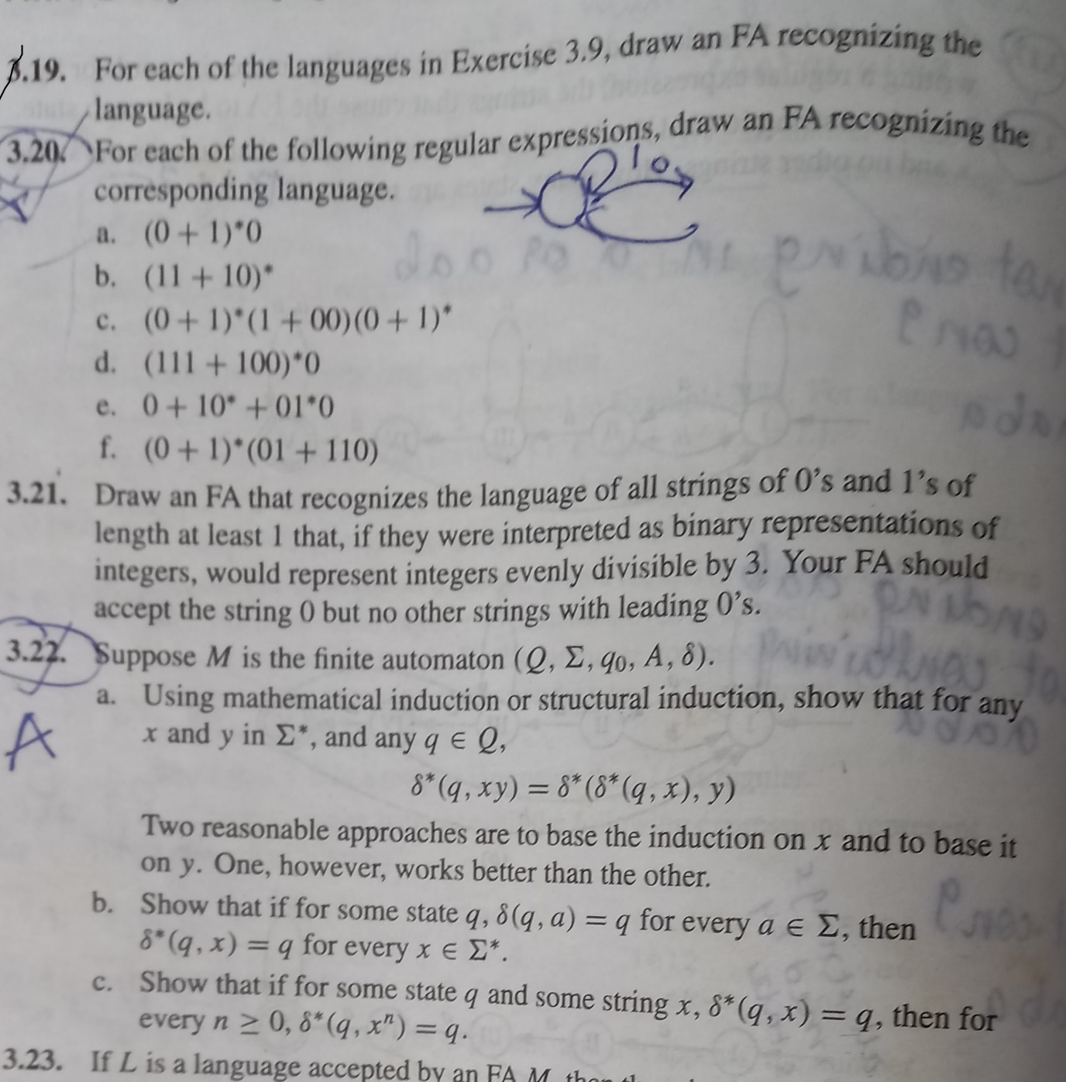

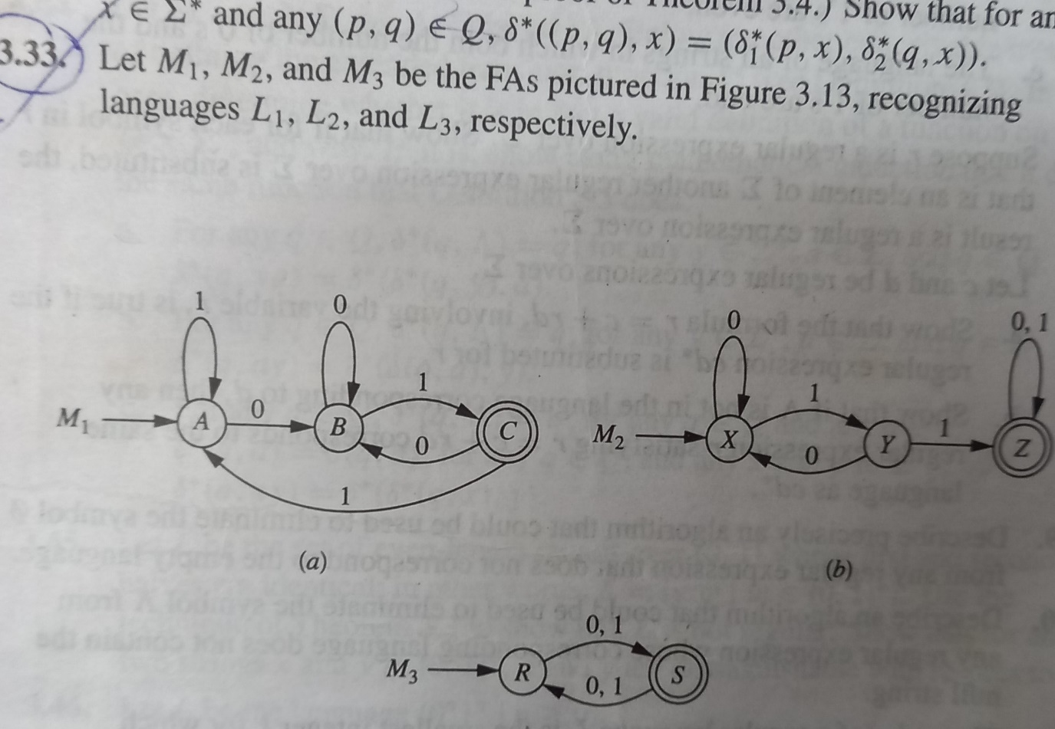
Draw FAs recognizing the following languages:
a. L1 U L2
b. L1 ꓵ L2
c. L1 – L2
d. L1 ꓵ L3
e. L3 – L2

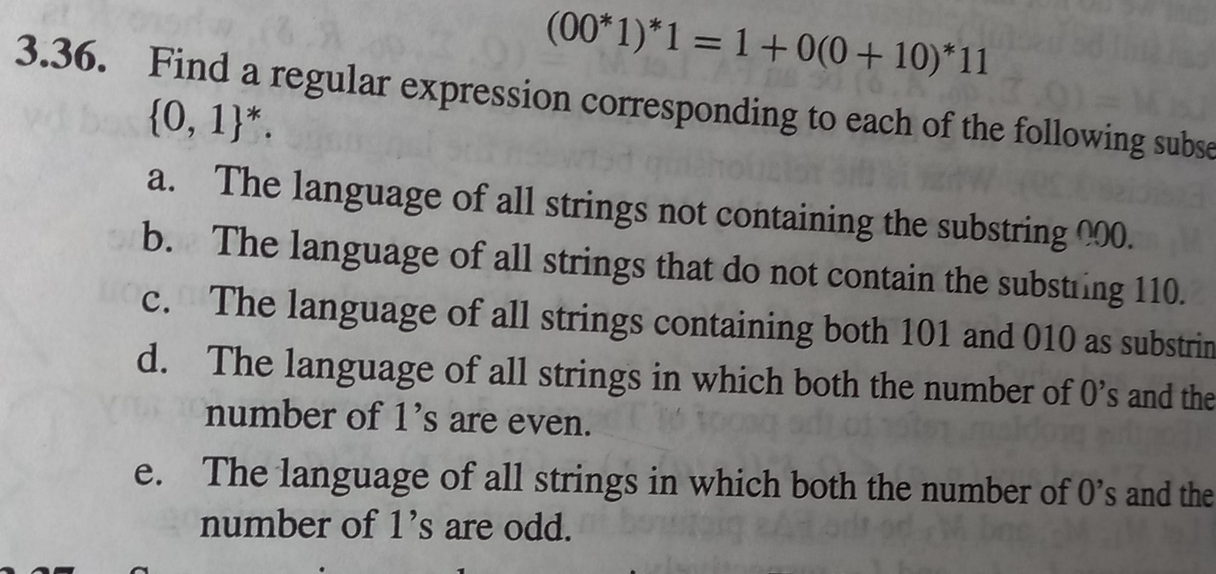
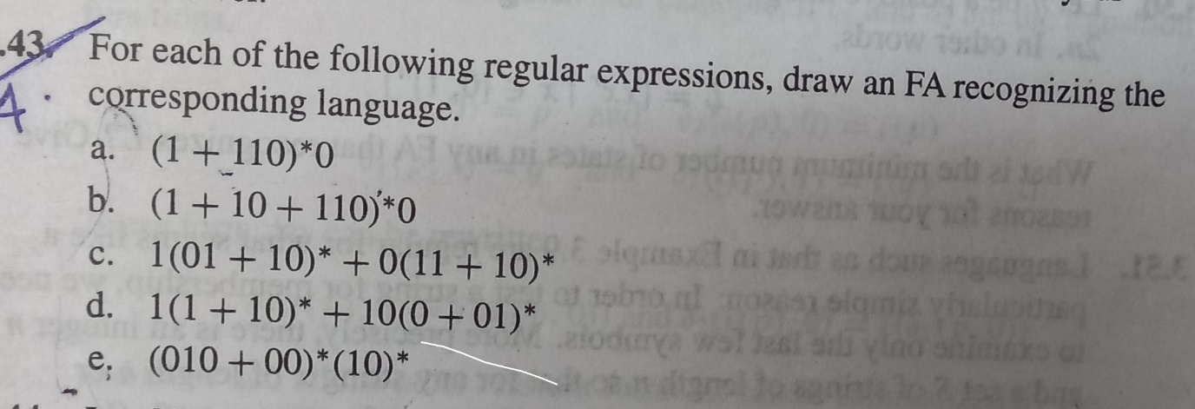

Prepared By:

Ms. Rimi Gupta
Asst. Prof
SVIT,vasad

1*(01)*0*=

{null, 11111111, 0000000,01010101, 111…0101,111100000,01010000,111110101010000….1010101…

{011,0101,

(r(r+s)*)+ == { r,rrrrr,rsssss,rrsrrssrsrsrrsrs…}
=r.(r+s)*

